**01. Import the Python Libraries**

**02 Load the dataset**

**03. Display the first and the last 5 rows of the data**

**04. Check for the Types of the Data in the Dataset**

**5. Remove the irrelevant columns**

**6. Renaming the columns**

**7. Check for Duplicate Rows**

**9. Outliers Detection**

**10. Visualization Plots**

**i. Scatter Plot**

**ii. Histogram  
**

**iii. Heat Maps**

**Machine Learning Pipeline**

**Task 2**

**7. Display the Descriptive Statistical Features of the DataFrame  
**

**8. Handling Missing Data**

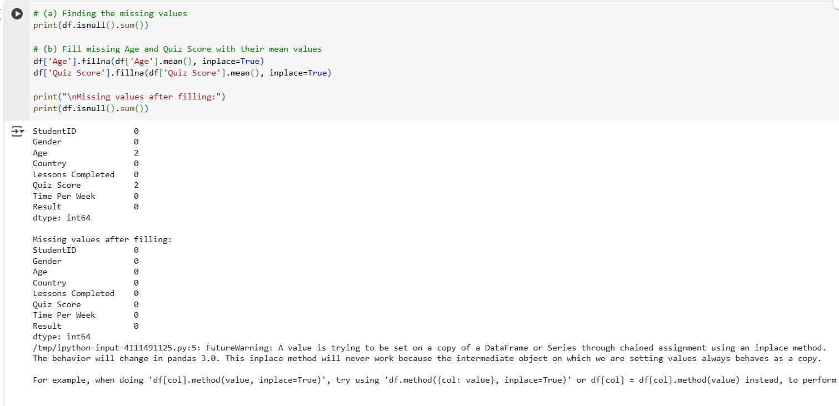

**9. Encode Categorical Data**

**10. Add a New Feature "Engagement Level"**

**11. Normalize numerical features using MinMaxScaler**

**12. Preview the final preprocessed dataset**

**A Simple Machine Learning Model**

**1. Prepare features (X) and label (y) for model training**

**2. Split data into training and testing sets**



